**Experiment No. - 4**

**Name-** Bhavesh Kewalramani

**Roll No.-** A-25

**Section-**  A

**Semester-** 6th

**Shift-** 1st

**Aim:**

To create a Sequence and Collaboration Diagram to represent the dynamic view (behavior) of the IRCTC Reservation System. (Online Ticket Booking)

**Theory:**

# **Sequence Diagram**

The sequence diagram represents the flow of messages in the system and is also termed as an event diagram. It helps in envisioning several dynamic scenarios. It portrays the communication between any two lifelines as a time-ordered sequence of events, such that these lifelines took part at the run time. In UML, the lifeline is represented by a vertical bar, whereas the message flow is represented by a vertical dotted line that extends across the bottom of the page. It incorporates the iterations as well as branching.

## Purpose of a Sequence Diagram

1. To model high-level interaction among active objects within a system.
2. To model interaction among objects inside a collaboration realizing a use case.
3. It either models generic interactions or some certain instances of interaction.

## Notations of a Sequence Diagram

### **Lifeline**

An individual participant in the sequence diagram is represented by a lifeline. It is positioned at the top of the diagram.

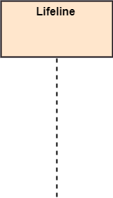

### **Actor**

A role played by an entity that interacts with the subject is called as an actor. It is out of the scope of the system. It represents the role, which involves human users and external hardware or subjects. An actor may or may not represent a physical entity, but it purely depicts the role of an entity. Several distinct roles can be played by an actor or vice versa.



### **Activation**

It is represented by a thin rectangle on the lifeline. It describes that time period in which an operation is performed by an element, such that the top and the bottom of the rectangle is associated with the initiation and the completion time, each respectively.

28.6M

664

OOPs Concepts in Java

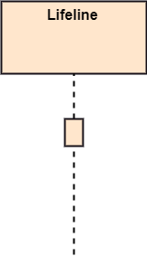

### **Messages**

The messages depict the interaction between the objects and are represented by arrows. They are in the sequential order on the lifeline. The core of the sequence diagram is formed by messages and lifelines.

Following are types of messages enlisted below:

* **Call Message:** It defines a particular communication between the lifelines of an interaction, which represents that the target lifeline has invoked an operation.  
  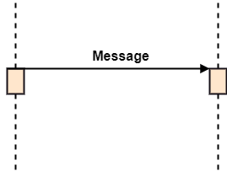
* **Return Message:** It defines a particular communication between the lifelines of interaction that represent the flow of information from the receiver of the corresponding caller message.  
  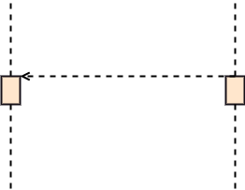
* **Self Message:** It describes a communication, particularly between the lifelines of an interaction that represents a message of the same lifeline, has been invoked.  
  Sequence Diagram
* **Recursive Message:** A self message sent for recursive purpose is called a recursive message. In other words, it can be said that the recursive message is a special case of the self message as it represents the recursive calls.  
  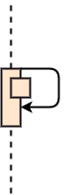
* **Create Message:** It describes a communication, particularly between the lifelines of an interaction describing that the target (lifeline) has been instantiated.  
  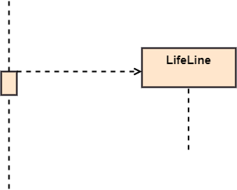
* **Destroy Message:** It describes a communication, particularly between the lifelines of an interaction that depicts a request to destroy the lifecycle of the target.  
  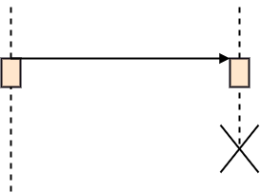
* **Duration Message:** It describes a communication particularly between the lifelines of an interaction, which portrays the time passage of the message while modeling a system.  
  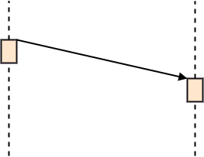

### **Note**

A note is the capability of attaching several remarks to the element. It basically carries useful information for the modelers.

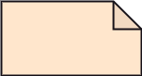

## Sequence Fragments

1. Sequence fragments have been introduced by UML 2.0, which makes it quite easy for the creation and maintenance of an accurate sequence diagram.
2. It is represented by a box called a combined fragment, encloses a part of interaction inside a sequence diagram.
3. The type of fragment is shown by a fragment operator.

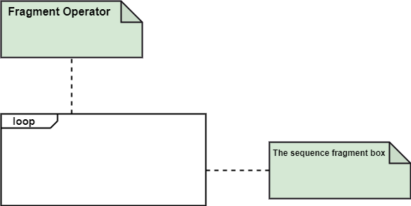

### **Types of fragments**

Following are the types of fragments enlisted below;

|  |  |
| --- | --- |
| **Operator** | **Fragment Type** |
| Alt | Alternative multiple fragments: The only fragment for which the condition is true, will execute. |
| Opt | Optional: If the supplied condition is true, only then the fragments will execute. It is similar to alt with only one trace. |
| Par | Parallel: Parallel executes fragments. |
| Loop | Loop: Fragments are run multiple times, and the basis of interaction is shown by the guard. |
| Region | Critical region: Only one thread can execute a fragment at once. |
| Neg | Negative: A worthless communication is shown by the fragment. |
| Ref | Reference: An interaction portrayed in another diagram. In this, a frame is drawn so as to cover the lifelines involved in the communication. The parameter and return value can be explained. |
| Sd | Sequence Diagram: It is used to surround the whole sequence diagram. |

# **UML Collaboration Diagram**

The collaboration diagram is used to show the relationship between the objects in a system. Both the sequence and the collaboration diagrams represent the same information but differently. Instead of showing the flow of messages, it depicts the architecture of the object residing in the system as it is based on object-oriented programming. An object consists of several features. Multiple objects present in the system are connected to each other. The collaboration diagram, which is also known as a communication diagram, is used to portray the object's architecture in the system.

## Notations of a Collaboration Diagram

Following are the components of a component diagram that are enlisted below:

1. **Objects:** The representation of an object is done by an object symbol with its name and class underlined, separated by a colon.  
   In the collaboration diagram, objects are utilized in the following ways:
   * The object is represented by specifying their name and class.
   * It is not mandatory for every class to appear.
   * A class may constitute more than one object.
   * In the collaboration diagram, firstly, the object is created, and then its class is specified.
   * To differentiate one object from another object, it is necessary to name them.
2. **Actors:** In the collaboration diagram, the actor plays the main role as it invokes the interaction. Each actor has its respective role and name. In this, one actor initiates the use case.
3. **Links:** The link is an instance of association, which associates the objects and actors. It portrays a relationship between the objects through which the messages are sent. It is represented by a solid line. The link helps an object to connect with or navigate to another object, such that the message flows are attached to links.
4. **Messages:** It is a communication between objects which carries information and includes a sequence number, so that the activity may take place. It is represented by a labeled arrow, which is placed near a link. The messages are sent from the sender to the receiver, and the direction must be navigable in that particular direction. The receiver must understand the message.

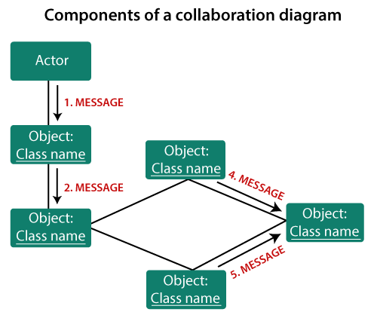

## When to use a Collaboration Diagram?

The collaborations are used when it is essential to depict the relationship between the object. Both the sequence and collaboration diagrams represent the same information, but the way of portraying it quite different. The collaboration diagrams are best suited for analyzing use cases.

Following are some of the use cases enlisted below for which the collaboration diagram is implemented:

1. To model collaboration among the objects or roles that carry the functionalities of use cases and operations.
2. To model the mechanism inside the architectural design of the system.
3. To capture the interactions that represent the flow of messages between the objects and the roles inside the collaboration.
4. To model different scenarios within the use case or operation, involving a collaboration of several objects and interactions.
5. To support the identification of objects participating in the use case.
6. In the collaboration diagram, each message constitutes a sequence number, such that the top-level message is marked as one and so on. The messages sent during the same call are denoted with the same decimal prefix, but with different suffixes of 1, 2, etc. as per their occurrence.

## Steps for creating a Collaboration Diagram

1. Determine the behavior for which the realization and implementation are specified.
2. Discover the structural elements that are class roles, objects, and subsystems for performing the functionality of collaboration.
   * Choose the context of an interaction: system, subsystem, use case, and operation.
3. Think through alternative situations that may be involved.
   * Implementation of a collaboration diagram at an instance level, if needed.
   * A specification level diagram may be made in the instance level sequence diagram for summarizing alternative situations.

**Conclusion:**

Sequence diagrams are a powerful tool for stitching together various diagrams. And as a result, they give you an opportunity to explore the connections between all the various elements. They are powerful and offer opportunities for incorporating more complex flows of execution than many other kinds of diagrams. Through the use of OPT, LOOP and ALT frames. While not required for your assessment, they represent your easiest course of action in terms of validating the design decisions that you are making. Collaboration diagrams are mainly used in object-oriented design phase. They are flexible to add new concepts in two dimensions hence occupy less space. In design phase objects are supposed to be provided with operations to perform. Collaborations are easily used for this purpose with the help of a Pattern which facilitate assigning responsibility to objects.